World Without a Passport

Wednesday, July 25 to Sunday, July 29

Application Form
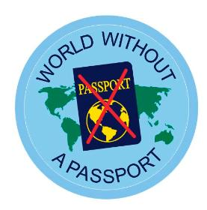
This event is being held at Provincial Office in St. John’s. It is being offered by the International Committee, for girls who are finishing 3rd year Guides and 1st year Pathfinders by June 2018. The theme of this event is Connecting Today with Yesterday. We will be exploring the connection between Europe and Newfoundland and Labrador by experiencing Commissariat House, The Rooms, The Railway Museum and Signal Hill Tattoo to name a few.
The cost is $130 + $19.50 HST for total of $149.50.
(Please note that there is often funding assistance from your District and Area Councils so please feel free to apply there as needed)
Deadline for registration form and fee is June 1, 2018
Payable to Girl Guides of Canada (if paying by cheque) or by credit card at Provincial Office.
Please send completed form and fee to:
Girl Guides of Canada Fax: 709-726-4045 Email: applications@ggcnf.org
Provincial Headquarters
63 Roosevelt Ave
St. John’s NL A1A 0E8
Kit list and further information to be e-mailed to each participant at a later date.
Name
Address
Parent email
Participant email
Phone
Any allergies
Any special dietary concerns

